Evaluation for Development – Beyond Aid

New Delhi
12 – 14 April 2005

Keynote Address
- Mary Chinery-Hesse

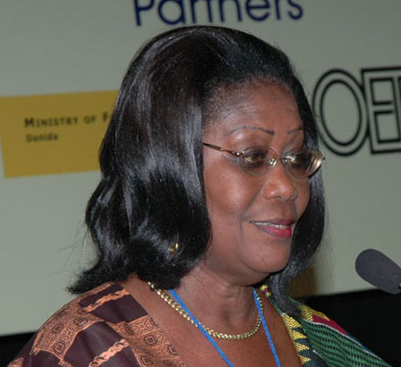

This conference occurs against a background of the devastation of the tsunami, the troubling aftermaths of the Iraq war and the sadness surrounding the unfolding crisis in Darfur. In my view, the international system and global architecture of peace and partnership have not faced as many challenges in the last fifty years as they do presently. While there is agreement about the crises the world faces today, there is just as much disagreement about means and ends. To this list should be added the escalating tragedy of HIV and AIDS and the havoc it has wrought on communities and families especially in Southern Africa, the inability of the majority of developing countries of the South to cope with and manage the impact of globalization and the growing disaffection with international development.

There is no doubt that we witnessed impressive gains in human development in the 1960s and 1970s. But the last 20 years have seen some sobering reversals and disquieting differentiations between countries of the North and South and between and within countries of the South.

How has Africa, home to over 500 million fared? As I have noted above, the picture is not a happy one. In 1998, 291 million of its people lived on less than one dollar a day and because of HIV and AIDS, estimates project that 124 million are likely to die before the age of 40. According to a 2001, World Bank study, “African Poverty at the Millennium,” between 1990 and 1995, 205 million people had no access to health services and 249 million were without safe drinking water. African countries have suffered a sharp decline in living standards over the last two decades and estimates show that since the 1950s, its share of world trade has shrunk from 3% to less that 1% today. Compounding the problem is Africa’s escalating brain drain. In Zimbabwe alone, where 25% of the adult population is HIV positive, in the last five years, the country has lost well over 80 % of government trained doctors and nurse to foreign shores. These are chilling statistics especially when one considers the vast natural wealth some of the African countries have and the fact that the situation may very well be worse today than it was only a few years ago. Clearly aid alone --- which has also shrunk over the years--- without debt relief and favourable terms of trade has proved all too inadequate to tackle the challenges most African countries face. While there is HIPC, evidence also shows that the processes are cumbersome, costly and slow and it has taken a considerable number of years for only five countries to qualify for debt relief. As many critics declare, (among them Joseph Stiglitz’s assessment in Globalization and its Discontents, 2002), globalization as presently constituted is not working for many of the billions that live in abject poverty and indeed for most of the poor countries of the world.
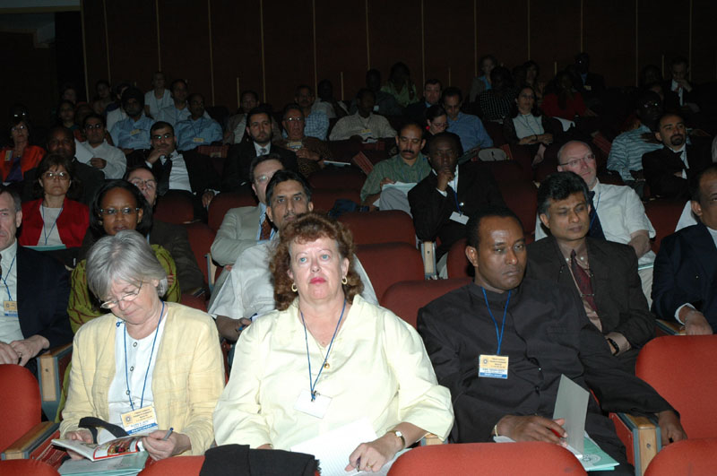
There is an ever increasing chorus of skeptics and dissenters regarding the seemingly elusive progress international aid was intended to bring about. Indeed some have argued that aid is useless while others continue to argue for a more compassionate and generous world regime to offset and indeed realize the potential benefits that globalization and development aid can bring. Nonetheless, few among us would argue about the need for a rethinking of past paradigms. Fewer still would argue against the need for developing countries to take stock of the past and tap into national energies to drive a more results-driven national development agenda and to tackle poverty aggressively. The overwhelming evidence suggests one thing: Development needs to reinvent itself: it must face its critics, not with tired formulas but with a new and robust architecture that addresses the burning issues of the day with renewed vigour. Development practitioners need to adopt innovative approaches to development evaluation that focus on measurable results and development effectiveness.

Given this and the recent reminders of new and intractable challenges that poverty, wars and the calamity of disease and natural disasters bring, “Development Evaluation - Beyond Aid “ is an apt theme for this conference. How can development evaluation move from the evaluation of good intentions and good projects to evaluating for changes in people’s lives? How can development evaluating for development results move from bean-counting and dollars spent to a focus on expanding opportunities for many and making human development and rights-based approaches the yardstick by which we measure our success and failures and those of our development partners.

Fortunately, the last ten years have seen changes and major shifts in development paradigms informed by the need to rethink what constitutes development. In the early part of this decade this culminated in the Millennium Declaration in 2000 and the 2002 Monterrey consensus on financing for development and the need for both donors and developing countries to focus on results and development effectiveness. In September 2000, 188 member states of the United Nations (UN) agreed to halve the number of the absolute poor and hungry by 2015. All in all, they committed themselves to eight critical goals, the Millennium Development Goals (MDGs). These, (if properly supported, systematically monitored and evaluated for their development outcomes and how they will reduce inequalities and expand opportunities for the poorest of the poor at global and national levels), should make a significant dent on the ills of today. Most notably the MDGs should be seen as a first concerted move by world leaders to set targets and clear indicators by which development efforts by national governments and the aid community should be evaluated. MDGs signal renewed efforts to focus on poverty reduction and reach global compacts that may promote development effectiveness through mutual support and a shared responsibility.

If the adoption of the MDGs is the most visible manifestation of these recent changes, equally important is the proliferation of forums and mechanisms for harmonizing approaches especially among donors. The Rome Declaration on policy harmonization and the UN reform speak to the fast paced change and need to focus on development results, build capacities and promote national ownership and broad based participation in the planning and evaluation of development and aid. Indeed there is a sea change in thinking on how we measure results and whose results we should measure. There are debates and arguments on what we should measure and most important, there are questions on the relevance of measurements and, assessment if they are not owned and driven by those affected by the policies or development programmes. The focus on managing for results and growing convergence of thinking on how to promote development effectiveness suggests that all or most of us agree that development strategies that work best are those that are country led, country driven and country owned and, may I add, evaluated within the prism of national development goals and targets.

The other changes that have relevance for development evaluation are the emergence of multiple voices in developing countries clamoring for accountability on the part of governments, the mushrooming of national and regional evaluation associations and national monitoring and evaluation systems (M&E) – the latter a positive by product of PRS, SWAPs and SIPs and direct budget support. These are hopeful signs and tremendous opportunities for development evaluation to make significant contributions to development.

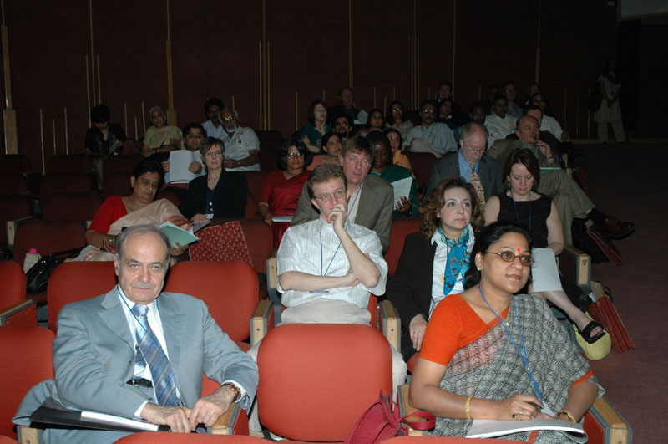
Let me hasten to add that, notwithstanding the formidable challenges a number of African countries face, there are some exhilarating signs and positives developments too. Where there was Rwanda ten years ago, we now have genuine efforts to avert conflict before it starts and to focus on durable solutions. Where elections were a call to arms and citizen arrests, we have emerging democracies where peaceful coexistence is the norm. Mozambique and Ghana’s recent elections and Sam Nujoma of Namibia’s stepping down only a few weeks ago instead of changing the constitution are positive trends that point to the future. In place of “gentlemen’s” clubs, we now have NEPAD’s peer review mechanism setting standards and raising the bar on how and what development evaluators should evaluate.

To be sure, there are still contested spaces and disagreement about strategies in most countries, but there are many conversations taking place about development, about peace dividends, about change and Africa and Africans’ place in a rapidly changing world. The challenge for IDEAS and development evaluation that goes beyond aid is to capture these new frontiers and turn them into a constructive dialogue about positive outcomes and how to change people’s lives. For example, the dialogue should be about MDGs and how aid is in fact helping countries to reach these targets not about the efficacy of aid alone.

In my view development evaluation has the potential to become an arsenal in the service of development if we broaden the concerns beyond our individual organizational concerns and objectives and focus on national goals and development effectiveness.

Evaluation development should speak to issues of human development and human security, to issues of gender equality and, most important, to issues of partnerships founded on mutual respect and the willingness to learn from the diversity of experiences and cultures. The real users of development evaluations are not the development agencies that commission them but the citizens and publics of developing countries that are increasingly demanding transparency and accountability from their governments. For a growing number of countries and even for the poorest ones, development aid is but a very small percentage of national resources and public sector budgets. If development evaluation focused on results and targeted national development outcomes as the yardstick for assessing performance, effectiveness and impact, there would be a sea change in the attitudes of the decision makers of the South. Development evaluation would become a learning tool for both decision makers and the governed and an accountability tool for the many institutions such as parliaments, think tanks, civil society groups and the larger public. The goals of development evaluation should be to foster and nurture a culture of self assessment within governments by demystifying the processes and shifting the focus to nurturing and promoting ownership and development outcomes at national level.

There are three areas I strongly believe call for fresh ideas on the part of development evaluation.

First, HIV and AIDs. Do we have the knowledge and tools as evaluators and development thinkers and practitioners to measure the right phenomena in a way that galvanizes action, individual and collective response and mutual responsibility to avert further disaster?

Second, conflict prevention and peace. Why do conflicts persist and are our evaluations making the right correlations between access to resources and control, poverty, scarcity and want and the roots of war? How can human security be nurtured and protected ex ante or are our evaluations, like the eloquent story of a gifted historian and story teller, coming far too late to make a difference?

Third, globalization, debt, migration and dislocation and marginalization of the human needs and rights within countries and between countries. Are our evaluations capturing the facts and fashioning these in ways that make decision makers react and make evidence-based decisions? Can we use evaluations to capture the reality of the most vulnerable and value those evaluations that lead to policy shifts in issues of human development and security rather than merely the accomplishment of project outputs?

It is my view that development evaluation has the potential to refocus attention on the big issues of the day and to seize the opportunities to promote outcomes that can reverse the negative trends.

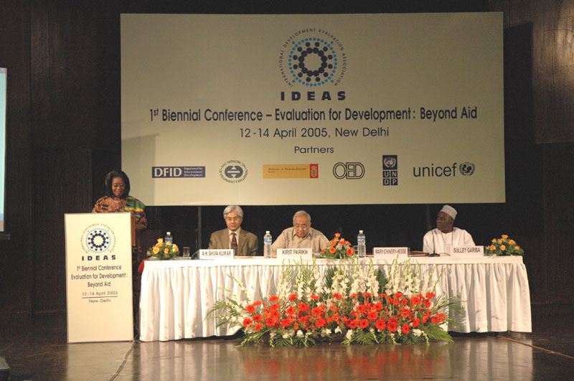
To go beyond aid, development evaluation should be neither about accounting to donors nor should it be the preserve of technical specialists fielded into offices of overburdened officials, punctuated by all too brief forays into the outskirts of the capital to “see” the project. We must challenge ourselves to take novel approaches and seek to transform the practice of evaluation into a learning tool that can contribute to social transformations and real changes in the lives of people. The global consensus around MDGs, UN Reform, national ownership and treating the country as the focus of our evaluations, to name but a few of the emerging trends, provide exciting opportunities for IDEAS and its members to forge a new partnership for change – a change that will move the debate on development effectiveness out of the hallways of international development conferences to form the basis of a larger notion of accountability that will resonate with the citizens of the developing world.

The issue of who uses the findings of development evaluations is also fundamental to the changes that need to be considered if evaluation development is to move beyond aid.

Evaluation should contribute to providing evidence based decision making
on emerging issues. In Africa, for example, how to effectively manage and respond to direct budget support mechanisms, PRSs and MDGs suggest that to be of relevance development evaluation must assist governments and the larger publics to tackle and respond to these challenges and opportunities.

In some countries national M&E systems and full fledged national independent evaluation units have been created, parliaments are becoming more assertive and regional and evaluation associations such as the African Evaluation Association and the Asian Evaluation Association and indeed IDEAS itself are on the rise. How development evaluation responds to these nascent changes and the new dynamics governing development practice will ultimately determine its value addition to the biggest challenge of development itself---expanding and enhancing human potential and
People’s capabilities, enlarging our choices human freedoms and safeguarding human rights for all.

In my view the challenges for development evaluation that goes beyond aid and for IDEAS are multifaceted. Let me in closing share a few of these with you.

First, to be relevant to the issues of the day, development evaluation will need to simultaneously look back and reach forward in order to create innovative systems of ideas and thought that challenge orthodoxy thinking.

Second, development evaluators will need to think “inside” as well as “outside” of the box. For the evaluator from or working on issues of the South, thinking inside the box means (a) taking local realities as the point of departure for setting the evaluation agenda and constructing the evaluation framework and (b) drawing upon the wealth of local knowledge systems to enrich the discourse on methodologies and how to interpret local realities. Thinking outside the box entails taking giant leaps and taking on broader issue of the day to create evidence that will push the frontiers of the world discourse on the real causes of poverty and what needs to be done nationally and globally.

Third, development evaluation will need to work on how it can foster changes and bring about breakthroughs in knowledge on how to promote development effectiveness. An organization such as IDEAS which is a South-South think tank should put at the core of its agenda innovation, relevance and the quest for real time knowledge to solve burning issues of the day. HIV and AIDs, conflict prevention, environmental fragility and natural disaster preparedness, migration, immigration, dislocation and human security, to suggest just a few, would seem to warrantee attention.

Finally, evaluation development will need to address the capacity needs of developing countries and partners in this area to meet the growing demand for nationally owned evaluations and to strengthen the emerging national M&E systems and independent evaluation units and, no less important, to embolden the voices of civil society and national and regional evaluation associations. The participation and inclusion of the latter in the family of international global evaluators should measurably enhance the quality and relevance of development evaluation to contributions

In conclusion, I would like to underline that to count, development evaluation beyond aid should be about problem solving and raising difficult questions. To count, evaluation development should be about bringing together the thinkers and the public and the decision makers and those affected by the decisions as well as the North and the South in a dialogue of equals. A new global architecture of evaluation development - fashioned on diversity and inclusiveness and simple and mutually understood performance criteria and full access to knowledge—is long overdue.

