Evaluation for Development – Beyond Aid

New Delhi
12 – 14 April 2005

Securing Development
- Anuradha M. Chenoy

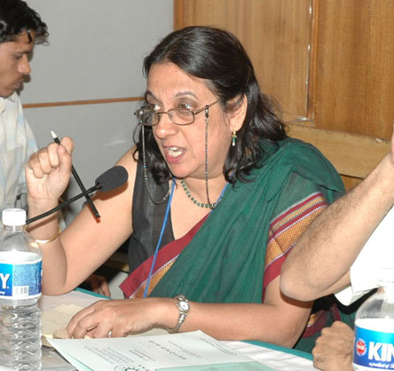

Development programs and aid despite best intentions need a secure environment to be effective. Development itself cannot ensure security to people, communities or states and conditions of insecurity reverse the gains of development. The dialectical link between security and development is necessary and inevitable. This has been underlined by the Human Security Report and by the experience of development agencies. It is imperative that security be part of the development discourse. The questions that arise at the very outset however are whose security? What have been the short comings in the security discourse? And how can we over come these? How should security be evaluated? In this paper we develop a security-development dialectics to re-vision the development discourse.

Traditional Security, Conflicts and Dysfunctional States

The conventional understanding of security has been embedded in the protection of the state from military threats. The traditional methods of security emphasized state security; legitimized force as an instrument for security; and related to other states through a balance of power. While the more democratic and "stable" states were able to resolve conflicts by providing social justice and building institutions for negotiation between communities most developing states were caught in conflicts, insecurity and some became ‘dysfunctional states’ (DS). So in the last decade, 43% of the countries in the lower half of the human development index were at war, while only 5% of countries in the top third of the HDI were in conflict. It is thus imperative to view the nature of conflict and insecurity to relate them to development.

Conflicts have been viewed and evaluated within the traditional security discourse and states involved have attempted to ‘manage’ these conflicts through the concerns of national security. These conflicts however, have common indicators that relate to wider issues of identity and rights and therefore it is pertinent to look at these conflicts through a rights based framework. The rights based frameworks that come close to understanding these issues are the Human Security concept and the feminist understanding of armed conflict. This is especially so, since all but three conflicts registered in the period 1990-2001 were internal in nature. The three territorial ones were Iraq-Kuwait; Ethiopia-Eritrea; and India –Pakistan. The rest (98%) were related to issues of governance and institutional mechanism of power sharing and rights in the political system as we show below.

An analysis of the currently unresolved armed conflicts [Table I] shows many common features that need to be taken into account when analyzing states at risk. This common denominator combines lack of development; inequity; denial of rights; democratic deficit; gender and minority discriminations; exclusions, and rising aspirations. In each of these conflicts this mixture has different variables. For example, India, Sri Lanka, Turkey has democratic structures, yet many ethnic minorities and religious minorities feel excluded.

Of the twenty eight locations with unresolved and prolonged conflicts that we analyze, [Table I] twenty five are in Developing Countries, are former colonies and fall in the low human development category. Almost twenty three of the disputes are based on ethnic/ identity disputes, two are against occupation and two are left wing peasant rebellions. Almost all of these states have more than one conflict; have had a history of inter-community/ sectarian violence, gender and caste/class based violence and unrest. Thus each of the states in conflict has multiple parameters of conflict. And all are linked to human insecurity issues.

An analysis of these conflicts show that most are rooted in civil society and extend into state structures, social and political institutions. For instance, one would find class, caste, ethnic, religious, gender based biases, practices and policies in most social, economic and political institutions. These practices extend to social interaction, employment, cultural practices and laws that can be subliminal or overt but are nonetheless present. For example, the Tamils in Sri Lanka, Kurds in Turkey; Ache and Moro people all have a history of discrimination from the dominant majority in their states. State policy and the majority community have practiced this discrimination in critical areas like language policy, educational institutions; job prospects and government decisions. These discriminations in civil society that are ignored by the state are the basic reasons for the conflict. Clearly then, minority rights and multi cultural policies are necessary to end these discriminations and for conflict resolution.

In most conflicts and dysfunctional states (DS) Sectarian/ethnic/fundamentalist/right wing political parties and movements reflect and use the social divisions in different ways. Such political parties base themselves as representative of one (religious) group specifically in opposition to the ‘other’ and use this as a primary method of mobilization. They create a threat perception of the minorities as ‘outsiders’ who are linked to the enemy ‘other’ and whose loyalty to the nation is suspect. For example the Sri Lankan Tamils were seen as ‘outsiders’; Right wing forces in India propagate that the Muslims are outsiders and loyal to Pakistan; In Indonesian ethnic riots the Chinese were seen as outsiders, similarly in all anti-ethnic riots and unrest, the minorities are first condemned as alien to ‘national cultures’. These parties and ideologies homogenize multiple traditions to create uniformity when none exists. Regimes in power/ centrist parties often do not mobilize sufficiently against such trends, remain divided on their strategies and tactics and fear political defeat if they do not succumb to ‘majority’ or populist politics.

The civil society groups and peoples movements in most of these states either have very limited space and influence, and in most of these conflict prone states are deeply divided and not a major force. In almost all of the conflicts in Africa, civil society remains non existent, and thus people to people or inter-community confidence building does not take place. In states where civil society groups link up with specific social movements, they have some say in mainstream politics. Some sections of the extreme left in some states like the Maoists in Nepal and (Naxalite-Maoists) in India; in Peru and Mexico are involved in armed anti-state movements. Extreme left wing (Maoist) movements are popular where ever there are instances of extreme poverty, and absence of justice. In India, most areas where tribal communities live and where they have been deprived of land rights and there has been de-forestation, the Naxalite Movement is supported by the local people.

The role of the state in most of these conflicts has been far from neutral. This is evident from the examples of Sudan; Liberia; Ethiopia; Israel; Rwanda; Nigeria, Sudan, etc. where the state has blatantly backed one particular ethnic community against others. With state backing, the level of oppression is much higher, than in circumstances where the state has a semblance of neutrality. The state in these cases has an official army that is used in the repression and in addition supports militia and vigilante groups. In such cases, abuse, human rights violation and possible genocide against one community become sharper and are prone to be covered up by the state.

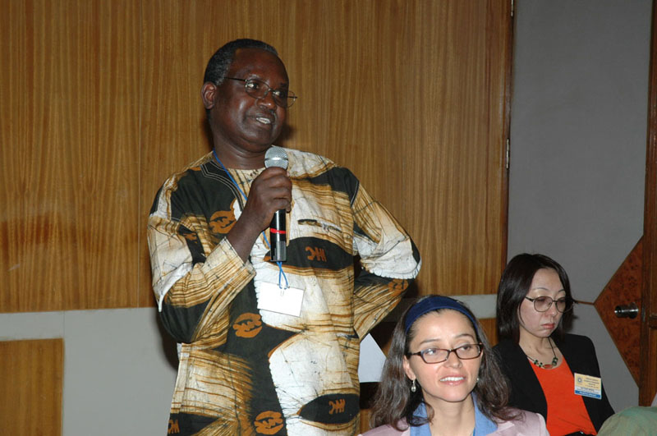
An analysis of each of the states in conflict [Table I] reveals how the regime in power has used the conflict for serving its interest. For example, the king of Nepal declared emergency, suspended the parliament and usurped power. In Pakistan the army has used conflict with India to abrogate democracy and install military governments. Most of the African states in conflict have authoritarian regimes and disregard for democratic culture and practice. This leads to political inequity between ethnic groups who then use a militia to gain power and privilege. In most of these conflicts, the ruling regime has constructed a nationalism based on ‘majority’ politics and has attempted to isolate or integrate the ethnic/tribal/religious minorities. Most of the democratic regimes in states with conflicts have used minorities and excluded people primarily as a vote bank; or used religion or language issues to homogenize people for electoral purposes; or used one religion/ ethnic group against another etc. In all these conflicts the state has resorted to tactics of majority militarist nationalism and sought legitimacy by evoking images of threat perceptions, territorial disintegration, and ‘national honour’. These exclusions lead to conflict situation and can be identified with states at risk of future conflicts.

In all these conflict ridden states, the armed forces have been used to control and manage dissent that gradually evolves into conflict. They have treated dissent and dissatisfaction of a group against state policies as law and order problems and attempted to use one faction against the other or repress the conflict, before trying to look for a negotiated solution. All these states where there is a history of conflict have promulgated highly draconian national security laws and legislation. In all the regions of armed conflict emergency provisions and Acts like special powers for the Armed Forces and paramilitary are operational. Armed Forces have special rights like conducting searches without warrants, destroying shelters that could be hideouts, granting wide discretionary powers to even junior officers, disallowing assembly or meetings of large numbers of people, and giving immunity to officers who have committed human rights violations. All these states show a record of systematic human rights violations especially in the region of conflict. Such laws that are meant to provide security actually lead to insecurity and alienation that feeds into the conflict and creates support and cadre for the conflict. An important step for conflict resolution should be a withdrawal of such national security legislation. This is especially so in the Asian conflicts, where despite democratic regimes, in areas of insurgency such draconian measures are used. Thus, while there is a semblance of democratic governance and institutions, these special Acts, are allowed to violate democratic norms in some areas.

Most of the conflicts have armed militias that operate on behalf of the conflicting sides. This militia is law unto itself in the region where it operates. They have access to small arms and even sophisticated weapons. They collect taxes, indulge in kidnapping, extortion, sale of drugs and are involved in a clutch of illegal activities. They are an integral part of the conflict economy and absorb unemployed youth, especially young boys and increasingly young women as cadre. In dysfunctional states, militias are the main controllers of political power and have a vested interest in the conflict as in Angola; Sudan; Congo and Somalia, where the militia operated illegal control over resources and controls trade.

Development funds that go into such states or even regions of conflict often find their way into the ‘black’ or illegal economy that sustains the conflict. For example, in Chad, the World Bank’s assistance in 2000 of US $ 4 million for developing oil pipelines was used to purchase arms for the civil war. Similarly, development assistance for millions of dollars in most conflict regions, has been given to states who themselves are partisan in the conflict and would disburse it to the majority or powerful communities. For example, the tsunami hit Ache province in Indonesia has complained that international aid has not come to their assistance. This example is repeated in the African conflicts. Clearly then, alternate methods of development assistance have to be rethought and assistance giver and taker have to be made more accountable.

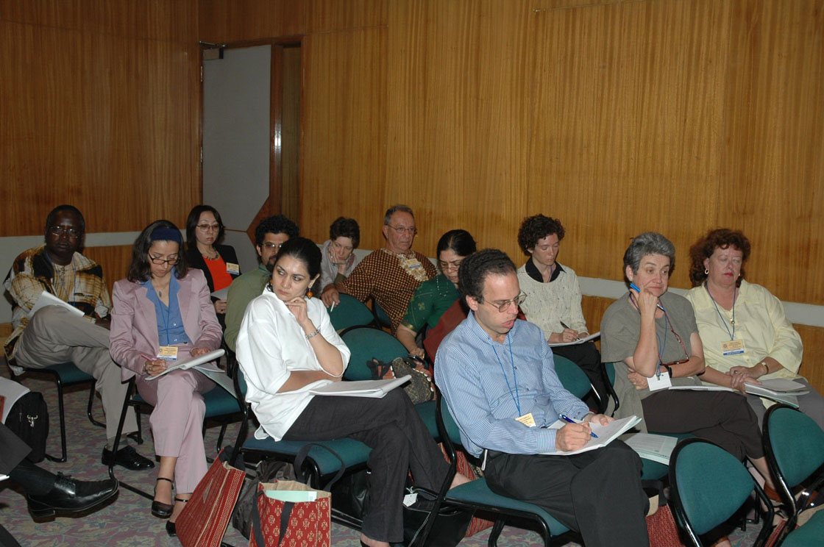
Most states that have attempted negotiations primarily after much bloodshed and terror, or after intervention from ‘outside powers’ [Thus conflicts like Cambodia, East Timor, Sri Lanka, Georgia, Palestine, etc have all seen international pressure.] But the basic issues remain unresolved. All states in conflict have seen increases in their military budgets, in the number of Armed Forces and acquisitions of weapons. States like Nepal, Sri Lanka, and African states have been doubling their defence expenditures and strength of their armed forces within a few years. The consequence is a militarization of their entire system. In many of these states official expenditure on military as percentage of GDP is higher than that on the expenditure on education and health combined. Two states are openly nuclear and two are known to have nuclear capabilities while others aspire to this. There is evidence of increasing militarization of all these states.

All these are indicators reveal that these states use militarist responses to ethnic / identity movements and that the policies of militarization lead to greater emphasis on defence expenditures and the use of militarist values in resolving essentially civil disputes. Such policies have lead to a spiral of violence in these societies, and a re-enforcement gender stereotypes, caste and class hierarchies as they legitimize aggressive nationalism and force.

The ethnic/ secessionist/anti-state movements in all these states also have many common features. Most of these anti-state movements begin as demands for justice or social change and are often based on ethnic sub-nationalism that incorporate ethnic-nationalist myths, symbols and strategies. Most of these movements have a number of factions and different strategic perceptions, tactics and goals and some of these groups have used violence against each other. Many of these movements have sections that use militant/ violent strategies, labeled as terrorism. Many of the movements are hierarchically organized, based on military principles and are ‘underground’. Most use women cadre in their operations, most of who are support cadre and lower in the hierarchy.

Thus, many ethnic secessionist and anti-regime/state movements valorize force, often because of the failure of other methods. The use of violence however, has its own logic that leads to militarization of these movements with all its problems. These kinds of approach to security where both the state and anti-state movements are highly militarized have implications for civil society that has been felt and documented all over Asia.

Implications

In all these conflicts the largest number of people who have been killed, hurt, maimed have been civilians. Non-combatants get marked as supporters and are subject to army grilling, searches, and women are especially targeted for abuse. All these conflicts have generated large numbers of internally displaced persons and millions of refugees. The Gender Development Index Ranking for most of these states is amongst the lowest in the World. Women have been subject to violence and degradation on the basis of ‘honour’. Women have been disproportionately affected by these conflicts, the largest numbers of those displaced and made refugees (70%) have been women. In most Asian and African countries women loose their status in society as widows, rehabilitation packages for women in all these conflicts have been lesser than those given to men and in many instances, women have not personally benefited from compensation since this has been taken over by the extended families. Since women symbolize the honour of their community they loose their autonomy during such conflicts since there is an attempt to keep them ‘secure’ at home. On the other hand, women who ‘belong’ to the ‘enemy’ are raped, since this violates the ‘honour’ of the entire community. In all these conflicts, rape and sexual abuse of women has been used as a method of punishment for the entire community.

Children have been caught in the crossfire in all these conflicts and have killed, maimed, traumatized, and militarized. Many of the conflicts there has been reported use of child soldiers, kidnappings etc. Conflicts orphans children, keeps them away from schools, all process that traumatizes, dehumanizes them and instills militarist values. In most conflict regions counter insurgency measures are carried out. These measures are aimed at destroying the infrastructure support base of terrorists. This has generally meant that the homes, workplaces, fields of ordinary people in these regions get destroyed, or marked as enemy territory. Thus infrastructure in conflict region is often destroyed.

Clearly then, an analysis of these conflicts establishes that human insecurity is at the base of all these conflicts. A varying mixture of under development; inequity; denial of social, cultural and economic rights; denial of political power and representation; to individuals and communities leads to resentments and aspirations that get transformed to militancy if they remain unfulfilled. This is the basis of conflict and a marker for states at risk of breakdown. The argument that development alone can alleviate conflict does not work. If it were so, many other states would still be embroiled in armed conflict. In fact if we study the 35 armed conflicts of the previous decade that ended in 2002, this endorses the point. Since many states continue to be in the low human development regime, but once they have some form of democratic space and communities have some basic rights and autonomy and ability for power sharing, conflicts tend to be negotiated rather than break out into protracted violence.

Human Security Paradigm

It has been argued that development will lead to peace and is a method of resolving conflict. Years of development assistance have however proved otherwise. The reasons are not far to see. One reason of course is that development assistance is lost in corruption. The second is that development assistance does not reach the right target. It has also been critiqued that development assistance is gendered. But the real question is what kind of development and why was not the development assistance made accountable? There is also the issue, that development assistance is sometimes tied to a particular agenda. For example some regime is given assistance to keep at bay left wing forces, despite the regime having violated human rights. This was especially the case during the Cold war, when most African conflicts were involved in great power rivalries. The other issue is development leading to the creation of institutional structures that will guarantee the rights to people and address the causes of the conflict? It is to address these issues that the Human Security paradigm should be used.

The Human Security concept is based on the premise that human rights and needs are necessary for security and that conflicts occur when rights are denied and needs repressed. The Human Security approach has evolved with the human development approach and has been brought together by the United Nations Commission on Human Security. Human Security seeks to compliment state security by broadening and democratizing security since issues like identity politics, or the neglect of social justice can become the central issues of national security, just as many inter-ethnic rivalries or sectarian conflicts have become. Here one must note that while most human security discourses tend to focus on individual rights, community rights are equally important especially in Third World societies.

Traditionally states had a monopoly over security and in many cases this concern mixed with regime security. States are concerned primarily with preserving their territory and sovereignty and furthering their perceived national interests. States that use primarily state-centred and militarist methods of security have failed to solve conflicts with just resolutions, they have only ‘managed’ or controlled conflicts temporarily with the use of force. If this status quo is intact they consider themselves secured. Human Security argues that people’s security should be a critical part of the states concern without diluting state interests. The people centred approach thus, is a radical departure from traditional security conceptualization. The Human Security concept however assumes that women’s security will follow ‘naturally’ if Human Security is accepted by states, we argue however that that gender needs to be built into the Human Security discourse, in the absence of which it would remain marginal. [Table II]

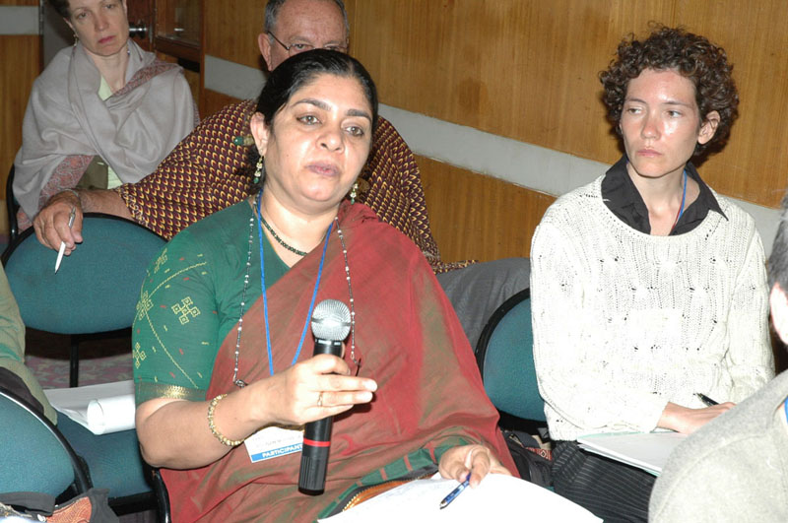
The Human Security approach broadens the realm of security to include almost all the needs of society from democratic, economic, identity and cultural aspirations. It recognizes the implications of gender and takes serious account of gender discrimination, the need for gender equity, and the implications of gendered violence. But in this conceptualization, gender is subsumed under the larger problem of people and since feminists argue that the concept of power is gendered, especially at times of armed conflict, then any approach that seeks security needs to recognize this. The fundamental premise of international relations theory continues to be Realist theory that sees the international political system as anarchic and thus values the need for military force as a currency of power. Once power is based on force, values associated with masculinity get privileged, and whoever exercises power, (men or women) valorize these values. Further, Realism argues that international relations remain disconnected from domestic issues, and thus ignores the vital issues such as identity politics, internal institutions and politics on external relations.

In many cases, states create insecurities for people when they do not follow rule of law and civil and human rights. States vary along the continuum from authoritarian to democratic systems, and within this continuum, the level and depth of democracy varies. Many democracies especially in the Third World continue to have a strong militarist or authoritarian presence and people and groups are marginalized because of gender, ethnic or communal lines. This leads to intractable conflicts like those we witness in Asia where the state has not been neutral, but a party to the conflict. The Human Security approach argues that internal threats arise when communities that have a sense of nationhood are denied rights, suffer poverty, inequity, injustice; or when majority and minority group interests clash. It is thus in the interest of state security that human rights are guaranteed.

Human security argues for rule of law based on secular and consent based constitutions, negotiated settlements, and institutionalization and greater use of international law for conflict resolution. It makes a plea for divided sovereignty, where the international community can intervene in cases of genocide and armed conflicts within states. It argues for increasing democratization, decentralization, people’s intervention on foreign policy and security; introduction of creative concepts like divisible sovereignty, shared territoriality; non-violent resolution. It supports a greater role of the United Nations in intervening in cases of prolonged armed conflict.

Conflict prevention and capacity-building strategies target mainly official authorities, not the communities (and community leaders), individuals at risk. This also means that protecting and assisting people in internal conflicts is seen primarily from the perspective of national sovereignty—and the principle of non-interference—instead of from a perspective of responsibility shared by states. State centred security tends to reflect the concerns of a narrow policy making elite, which are likely to exclude the views of women, minorities--ethnic and religious, marginalized communities. This exclusion itself eventually leads to movements that threaten the security of states. In current circumstances, more states are threatened from within than externally. This is especially true of almost all of Asia today. Human security pleads for the active participation of people at all levels of the security discourse. It perceptively argues that without the agency of people and grass root issues of safety cannot be resolved.

Human Security discourses argue that security can be empowering if it is linked to human rights and human development. The convincing argument is made that states that do not accept these social ethics cannot protect people from critical and pervasive threats and situations. In many countries that accept the conception of ‘peoples rights’ women’s rights are still not included in democratic and human right discourse. The goals of Human Security will be further widened, if special efforts are made to include women and the marginalized at all levels of institutions and policy planning. Human Security clearly shows the need for equity based development, and favours increased social sector spending on health and education. The experience of many African and Asian nations shows however, that development however does not mean the gender balanced development. The development decades left out many sections of society and especially women. As the Human Security Now Report (2003) shows, women own 2% of the land globally. Thus unless special provisions are made for women’s economic rights and efforts made to change economic and inheritance laws in favour of women, that gender inequity will continue.

Since the end of the Cold War, practitioners and academics alike have called into question this militarized conception of security and offered alternative views. The clearest opposition has come in the form of the Human Security approach that views security much more than the absence of violence. It encompasses human rights, good governance, access to education and health care, opportunities and choices to individuals. It advocates poverty reduction, freedom from want and fear. It is thus not just about protecting but about empowering.

The Human Security approach establishes that conflict data has been state centred and not people centred. These omissions have far reaching implications, as violence remains hidden when it does not fit into the state centric approach. The strategies to prevent and mitigate conflict then do not adequately address communities at risk, but rather official authorities. The national sovereignty perspective is restrictive rather than allowing for shared responsibility.

Conclusion

The continuation of conflicts, millions of deaths and displaced, child soldiers, women raped and humiliated, inter community violence, increased defence expenditure at the cost of social and developmental sectors indicate that conflict and development paradigms need radical revision. Development assistance that is given to states in conflict may be used by the regime in power to further specific agenda. Millions of dollars worth of development assistance has not led to the right kind of development of some states and in others, the process of development itself has been reversed when conflicts have risen and remain unresolved. Human security is a concept that offers long term solutions by incorporating entitlements to the traditional concepts of state security. The success of concepts like human security rests with civil society activists, NGO’s and social movements. A robust civil society is more effective in influencing foreign policy where a human security perspective is operative.

It is evident that the concept of Human Security is a necessary and empowering idea with potential to improve the terms of human existence when accepted by states. Human development cannot be ensured without human security. It is necessary to evolve gendered human security indicators to change the conception of national security and underline the importance and reality of human security. Such a paradigmatic shift will clarify how militarized notions of security add to insecurity of people and states. For this it is essential to for civil society to discuss people related security issues. To safeguard people’s security is a way to ensuring state security, for this it is necessary to broaden and humanize the concept of security itself.

Appendix 1 : Table 1

Country in Conflict | Reasons for Conflict | Structures of Representation | HDI and GDI  Rank.* | Militia | Human Rights record | International Intervention/ involvement of others | Numbers Killed and Displaced | Other Relevant Information
Afghanistan | Ethnic and NATO and US troops backed regime | New constitution and limited represesentative structures | --  -- | Ethnic militia | Violations | US and NATO | One and half million killed since 1978. millions woundd. | Poppy and opium production and trade+ oil,pipeline politics.
Algeria (1992) | Fundamentalism FIS/GIA struggle; Islamic groups | Military backed regime+ Democratic Institutions | 107  88 | Armed Islamic groups vs. State Army | Violations alleged. | French interest. | Up to 150,000  Thousands displaced.
Angola (1992) | Insurgency of Cabinda region; UNITA rebels. | lacking democratic; judicial; representative structures | 164  --  [one third national budget on military] | Armed militia of Cabinda-FAC;  UNITA militia | Wide scale HR abuse and sexual violence | Regional intervention | Over 30,000  Thousands displaced. | Control over oil and oil revenues linked with conflict economy
Burma/Myanmar (1988) | Insurgencies by Karens, Shaan; + anti regime | Military, authoritarian government | 118  107 | Government military vs Karen and Shaan militia. | Repression + Wide scale HR abuse | -- | Thousands killed; Two million displaced. | Heroin and opium production integrated with conflict economy; food scarcity.
Burundi  (1962 and again 1988) | Ethnic and Civil conflict since independence from Belgium. | Tutsi Tribe in power, repression over majority Hutu. Lack of representative or judicial structures. | 171-141 | Tutsi and Hutu militia do not recognize Arusha peace Accords | Genocide with 20,000 massacred In 1988. Mass rapes; child soldiers | African Union peace keepers and 2004 UN peace keeping Force. | 300,000 deaths since 1993; Millions displaced.
Chad (1965) | State control | Government vs. rebel groups from South; limited representative government but perception of lack of participation by all groups. | 165  135 | Militia from South and other militia | Government excesses and HR violations | Regional intervention | Over 50,000 | World bank report (2000) shows that Chad spent US $ 4 million world Bank oil pipeline project fund to purchase arms to fight civil war.
Colombia (1970s) | Left-right, FARC and ELN insurgencies; inequality/poverty |  | 64  55 | Paramilitaries and private armies to protect landlord; Left militias. | Repression + Wide scale HR abuse | USA involvement through troops | 200,000 since 1964.  Thousands displaced. | Vast inequality of wealth; Drug mafia and militia linked.
Cote d’Ivoire (2002) | Inter ethnic conflict; perceived discrimination of Christians of South by Muslims in North | Disputed elections; lack of democratic; judicial; representative structures | 161  134 | Connections between militia, security forces and economic interests | Repression + Wide scale HR abuse |  | Thousands displaced. | Conflict over resources
DR Congo (1998) | Interstate war; civil strife | Dysfunctional State; unable to manage multi-ethnic society | 167  136 | Tutsi led Rwandese Patriotic Front victorious over Rwandese Army, Rebel groups in East. | Ethnic Repression + Wide scale HR abuse | Regional intervention by Zimbabwe, Angola, Namibia.  UN Peace keeping presence (UNMOC) | 3.8 million dead due to conflict and disease. One million Hutus fled; 3.4 million displaced. | Illegal exploitation and trade of minerals; Conflict economy.
Ethiopia (1998) | Eritrea war; Gambella; Inter-ethnic conflict south west but not exclusively between Anuak and Nuer. | Dysfunctional State; unable to manage multi-ethnic society. | 169  139 | Ethnic militia | Ethnic Repression + Wide scale HR abuse | Regional conflicts impact. | Thousands killed and displaced. | Scarce natural resources-land and water + influx from regional conflicts
Georgia (1991) | Separatist movements in Abkhazia; South Ossetia. | Presidential democracy; but ethnic groups want more autonomy. | 88  -- | Insurgents and militia |  | Russia accused of supporting insurgency | Thousands killed and displaced.
India  India-Pakistan(1947) Kashmir(1987) North East (1947) | Territorial, ethnic disputes, Maoist movement; Terrorism: Kashmir; North East insurgency. | Representative government, federal system; secular laws. | 127  103 | Insurgencies in North east each with militia; Maoist rebel militia; Jehadi + terrorist groups in Kashmir. | Human right abuse in all areas of insurgencies. | Pakistan accused of supporting insurgencies; Bangladesh and Bhutan accused of arms support and shelters to insurgents. | Thousands killed in the various insurgencies and thousands displaced. | Maoist insurgency on the increase in 75 districts of 15 states in India, where there is extreme poverty, land alienation and injustice.
Indonesia (1960) | Ethnic movements Aceh; West Papua, Molucca islands, Sulawesi insurgencies | Military backed republic with political crackdown on ethnic minorities and rebels | 112  91 | State armed forces-TNI vs civilian movements; left; and rebels. | Minority oppression | -- | Thousands killed | Tsunami in December 2004 disaster in Aceh
Iraq  US occupation (2003) ; Iraq and Kurds | US war for regime change and occupation vs. Iraqi insurgency. | US installed representative regime. | --  -- | US and Iraqi Army vs. Iraqi insurgents. | Human rights abuse. | US and Western Coalition in control | Hundreds of thousands killed directly in war and indirectly by sanctions regime. | Oil politics and US interest in oil.
Israel (1987/92) | Palestinian struggle and Israel occupation | Israeli representative government | 22  22 | Israel State Army vs. Palestinian armed groups like Hamas. | Ethnic Repression + Wide scale HR abuse | US support to Israel | 120,000 killed and hundred thousands displaced. | Unequal division of resources, land and rights between Israel and Palestine.
Kenya (1991) | Inter-ethnic; iner-communal; kenyan vs. outsiders, etc. | Dysfunctional state; Truth and reconciliation commission established but no rule of law; security or justice. | 146  115 | Private militia and government militia | Ethnic Repression + Wide scale HR abuse | Regional conflict led to influx of refugees from sudan and Uganda increasing regional dimension of conflict. | 300,000 displaced since 1992; 10,000 deaths since 1999.
Liberia (1989-2003) | Armed conflict between government and rebels; war lords; control of resources | No rule of law; security or justice. | --  -- | Lord army; private militia; child soldiers | Severe violations | Sierra Leone’s assistance alleged.
Nepal (1996) | Maoist revolt with support from peasants. | Monarchy with limited representative government that has been suspended since 2004. | 143  119 | The Royal Nepal Army vs. the Maoist guerilla and rebels. In 3 years RNA doubled from 45,000 to 80,000. | Wide scale HR abuse |  | Over 20,000 in last decade. | Severe poverty of the peasantry and income differentials; economy based on foreign aid and tourism.
Nigeria (1997) | Ethnic, civil disturbances; insurgency; Yoruba vs Hausa in Southwest and North; muslims and Christians in north, etc. | Ethnic minorities and groups feel lack of representative, secular, representative institutions. | 152  124 | Each group has militia vs each other and government | Government excesses; rights and human rights violations. | Ethnic and regional tensions overlap. | 50,000 deaths and 800,000 displaced. | Oil is controlled by the MNCs. Community protests and conflicts around the oil profits. Environmental damage by oil companies; no benefits to local communities.
Pakistan (1960s/80s) | Coup and civil disturbances | Military Government with limited representative structures. | 144  120 | Fundamentalist groups and militia | Gender and human rights violations | India accused of intervening. |  | Military –bureaucratic elite control and inequality of wealth.
Philippines (1970s) | Moro uprising in Minadanao (1971), separatists + Left underground Communist party CPP/NPA | Democratic republic but Moro’s feel oppressed minority. + peasant rebellion led by CPP | 85  66 | National Peoples Army + Fundamentalist militia like Abu Sayaff and jemmah Islamiyah + vigilante groups and death squads | Minority rights violated. Socio-economic disparity between communities. | USA military presence, increased since 9/11 2001, for counter terrorism | 25,000 killed since 1969; over 50,000 displaced. | Wide inequality of wealth and poverty seen as contributing factor.
Russia (1992) | Chechen separatism | Democratic set up, but repression and military intervention in Chechnya | 63  56 | Russian army vs. Chechen war lords and militia. | Ethnic Repression + Wide scale HR abuse | European union and others proposing peace settlement | Over 30,000 killed since 1991 and many thousands displaced. | Control over oil pipelines major issue.
Senegal (1982) | Ethnic, Casamanc insurgency and civil conflict. | National Government, but South under-represented | 156  128 | Armed groups for Casamance freedom | Violations alleged
Serbia-Montenegro-Kosovo | Ethnic secession of kosovo | Representative institutions | --  -- | Kosovo liberation movements like Democratic league. | Violations | European Union | 12,000 killed
Somalia (1988) | Clan based conflict in noth west; inter clan and inter ethnic fight to control state. | D.S.Lacking institutions that represent and give rights to plural society. Somali National reconciliation Government. | --  -- | No state army but local and clan militias. | Rights and human rights abuses. | UN operations in Somalia (UNOSOM) 1992 ended in 1995 with no political process. UN arms embargo. | 400,000 killed directly and indirectly since 1991; and millions displaced. | War taxes by militia + mafia control of Miraa trade; warlord control trade between Somalia and Kenya. Famine
Sri Lanka (1980s) | Tamils, ethnic conflict; tamil minority denied share in power and feel oppressed. | Unitary democratic structures | 99  80 | State Army vs, Tamil Tigers (LTTE) | Rights and human rights violations by both state and Tamil militia.  Child soldiers. | Norwegian facilitators | 100,000 conflict related deaths | The North and East practically run by the LTTE; Tsunami disaster on coast.
Sudan (1983) | Civil conflict, South African-Christian wants autonomy from North-Arab Islamic+ inter ethnic+ Communal conflict; Darfur (2003); | Lacking institutions that represent and give rights to plural society. | 138  116 | Government backed militias like Janjaweed activly promoting violence in Darfur vs. rebels and civilians.+ other militia. | Severe human rights and rights violations + genocide; rapes, etc. | Governments of Eritrea; Ethiopia; Uganda accused of intervention. 2004 ceasefire violated. | Two million dead directly or indirectly since 1983. Four million displaced-largest in world. | Oil revenue used to buy weapons. Oil exploitation in South: Chinese, Malay companies involved. Control over land and water resources led to inter ethnic armed violence.
Uganda (1987) | Civil unrest/conflict: Lords Resistance Army-rebel group of Northern Acholi and Lango tribes vs. Government and others | Lacking institutions that represent and give rights to plural society. | 147  117 | Militia like Lords Resistance Army | Ethnic Repression + Wide scale HR abuse+ atrocities by militia and LRA | International criminal Court looking into atrocities of LRA | Tens of thousands killed; 1.3 million displaced; 20,000 children abducted as child soldiers and sex slaves.

n.d. – not documented
… – not available
*Source : Human Development Report 2003

Sources:
UNDP, Human Development Report 2002: Deepening Democracy in a Fragmented World (New Delhi: Oxford University Press, 2003)
SIPRI Year Book 2000 (Stockholm: SIPRI, 2001).
UNIFEM, World Women 2002 Report (http://www.unifem.org).
www.ploughshares.ca/imagesarticles/acro4/acrmap 2004 pdf
The Carnegie Commission on Preventing Deadly Conflicts, Carnegie Corporation of New York, http://wwwics.si.edu;
The World’s Armed Conflicts site http://www.jmk.su ;
Human Development Report 2003
Amnesty International yearbook 2003

Appendix 1 : Table 2

Security | Traditional security | Human Security | HS + Development
Security for Whom? | Primarily for States, some times for the regime. | For individual and for communities. | + Especially women and marginalized communities at risk.
Security from What? | From other state, military threats, non-state actors. | From inter ethnic/ sectarian/ communal conflicts, from poverty, injustice. From of lack of rights. | +From gendered structures, from militarism and structured and routine violence.
Security with what Methods? | State centred diplomacy, military force, national security laws, counter insurgency methods. | Rule of law, internal law, negotiated settlements, and international intervention. | +Gender sensitive domestic and international laws, non-violent and gender balanced negotiation
What Goals of Security? | To protect state, national interests. | To ensure social ethics, guarantee rights, social justice, equity, empowerment. | +To ensure gender based rights, equity and gender empowerment.
Arena of Security? | State to state, regional alliances, military alliances and collective security. | Inter connected security and human development | +Security connected with women’s rights, connections between women’s movements, social movements and international organizations.
Political Economy of Security? | High military expenditure, acquisition of missiles, weapons and nuclear technology. | Balanced social expenditures and decrease in military expenditures and equity in development. | +Gender balanced economic laws and distribution of resources. Equity
Theoretical Basis? | Realist theories, national security doctrines. Military strategies. | Human Security approach, democratic, human rights based theory. | +Feminist and democratic theory.

* Bajpai, Kanti. “Human Security: Concept and Measurement” The Joan B. Kroc Institute for International Peace Studies, University of Notre Dame, Occasional Paper #19 (August 2000) 33 pages Available at http://www.nd.edu/~krocinst/ocpapers/op_19_1.PDF

End Notes

Human Security Now2003, New York, Commission on Human Security, United Nations, 2003.
‘Dysfunctional States’ is a fuzzy conceptualization. However, we can broadly agree to use this for states that lack institutional structures for power sharing and change; and fail to provide basic rights, entitlements or security to the large mass of their citizens or use selective discrimination against certain groups/ minorities.
For example, in Asia the ethnic conflicts with some secessionist character are: Ache (and earlier East Timor) in Indonesia; Moro in Philippines; The Naga, Manipur, and other North East Indian ethnic conflicts and Kashmir conflicts in India; The Tamil Tigers in Sri Lanka; The separatist conflicts in Thailand. Two are struggles against Occupation: Palestine and Iraq; one is opposition to a military government: Myanmar; and one for economic and political change: Nepal; two territory based: India-Pakistan and North and South Korea. Afghanistan continues to have armed conflicts in several regions, This data is available from web sites like: The Carnegie Commission on Preventing Deadly Conflicts, Carnegie Corporation of New York, http://wwwics.si.edu; The World’s Armed Conflicts site http://www.jmk.su ; also WWW.ploughshares.armedconflcits2003. [International Peace Research Institute, Oslo]
SIPRI Yearbook, 2003, Armaments, Disarmament and International Security, Oxford University Press, SIPRI, Stockholm, Tables p.341-342.
? Commission on Human Security: Human Security Now, United Nations, New York, 2003; Ramesh Thakur, “A Political Worldview”, Security Dialogue, vol.35, no.3, September 2004, p. 347.
Kanti Bajpai, The Idea of Human Security, International Studies, 40,3, (2003), pp195-228. Also Liota, P.H., 2002. “Boomerang Effect: The Converging of National and Human Security”, Security Dialogue, vol.33, no.4, September 2004, p. 473-488; Lloyd Axworthy, “A New Scientific Field and Policy Lens”, Security Dialogue, vol.35, no.3, September 2004, p. 348; Anuradha M. Chenoy, “A Plea for Engendering Human Security”, International Studies, 42, 2, (2005), p167-179.
Anuradha M. Chenoy, op cit.
Cynthia Cockburn, “The Gendered Dynamics of Armed Conflict and Political Violence”, Caroline O.N. Moser and Fiona C. Clark, edited, Victims, Perpetrators or Actors? Gender, armed Conflict and Political Violence, (New Delhi) Kali for Women, 2001, p.13.
Carnegie Commission op cit.
The World’s Armed Conflicts site http://www.jmk.su
Human Security Now, op cit.
Human Security Now, op cit.
Human Security Now, op cit.

