Ideas for Development
by Robert Chambers
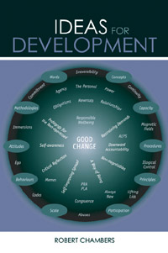
Price: $ 18.95
English Paperback 259 pages
Published July 2005 by Earthscan
ISBN: 1-84407-088-3 SKU: EAR-0883

* From one of the 'gurus' of development and author of the best selling Participatory Workshops
* Chock-full of provocative and actionable ideas drawn from four decades of development work and written in Robert Chambers' infectious and highly readable style
Our world seems entangled in systems increasingly dominated by power, greed, ignorance, self-deception and denial, with spiralling inequity and injustice. Against a backdrop of climate change, failing ecosystems, poverty, crushing debt and corporate exploitation, the future of our world looks dire and the solutions almost too monumental to consider.
Yet all is not lost. Robert Chambers, one of the 'glass is half full' optimists of international development, suggests that the problems can be solved and everyone has the power at a personal level to take action, develop solutions and remake our world as it can and should be. Chambers peels apart and analyzes aspects of development that have been neglected or misunderstood. In each chapter, he presents an earlier writing which he then reviews and reflects upon in a contemporary light before harvesting a wealth of powerful conclusions and practical implications for the future. The book draws on experiences from Africa, Asia and elsewhere, covering topics and concepts as wide and varied as irreversibility, continuity and commitment; administrative capacity as a scarce resource; procedures and principles; participation in the past, present and future; scaling up; behaviour and attitudes; responsible wellbeing; and concepts for development in the 21st century.
Robert Chambers is a research associate of the Institute of Development Studies at the University of Sussex, England. He is one of the world's most influential proponents of participatory development.

